Spark Exercise — Evidence of Execution
Daily Returns Dataset Transformation Pipeline — Azure Databricks (PySpark)

Task 2.1 — Parse and Match the Correct Article Object
df_stage2 row-count and match-count validation (1000 rows preserved, exactly 1 article match per row), plus the narrative answer explaining the _row_uid key, exploded article match, and left-join approach used to keep the row count unchanged.
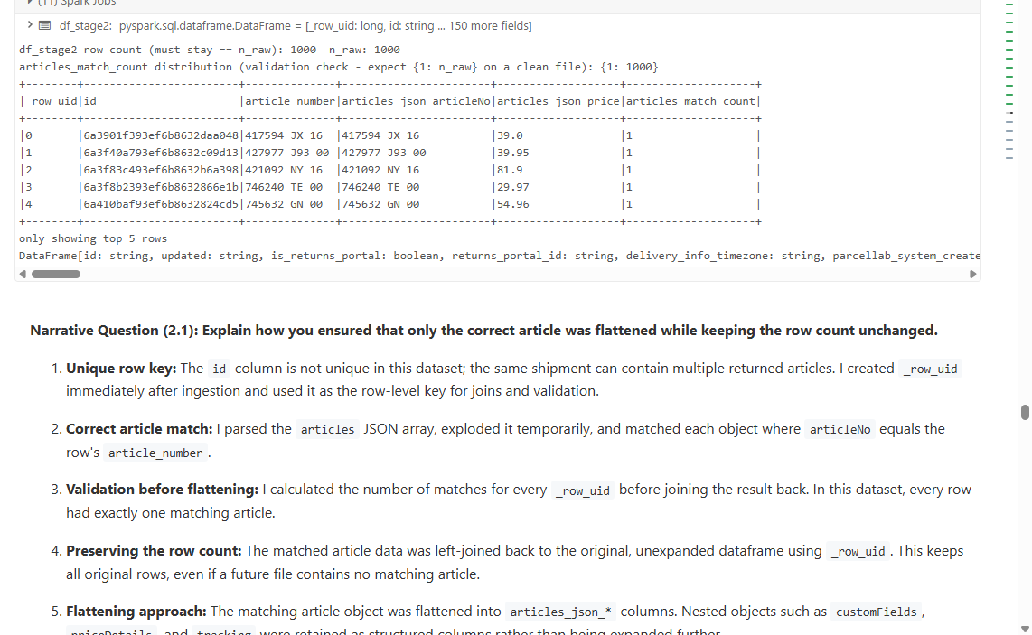

Task 2.2 — Transform the custom_fields Column
parse_custom_fields executed: 0 parse failures, df_stage3 row count matches n_raw (1000).
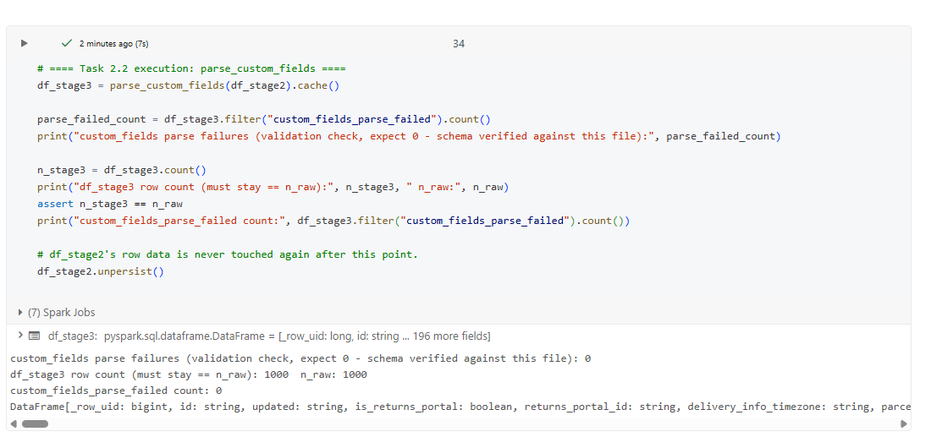

Task 3.1 / 3.2 — Identify and Repair Exception Rows
Real-data exception count: 0 (every row matched and parsed cleanly). Synthetic exception-demo rows SYN-A..SYN-F exercise every failure mode (parse failure, no match, custom_fields parse failure) since the real sample has none.
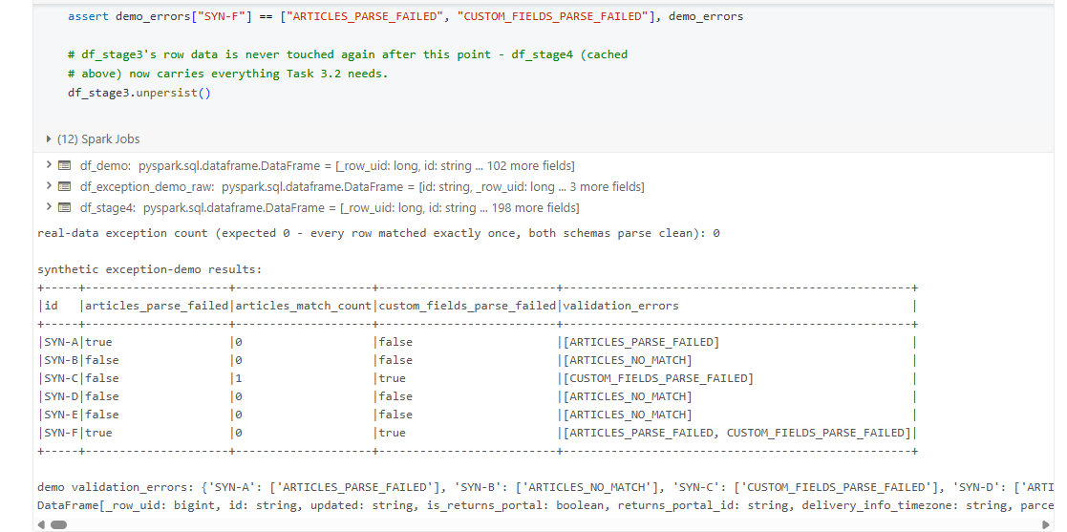

Repair attempt results: synthetic rows SYN-A and SYN-D fully repaired; SYN-B, SYN-C, SYN-E genuinely unresolved; real-data repaired/still-has-exception counts both 0.
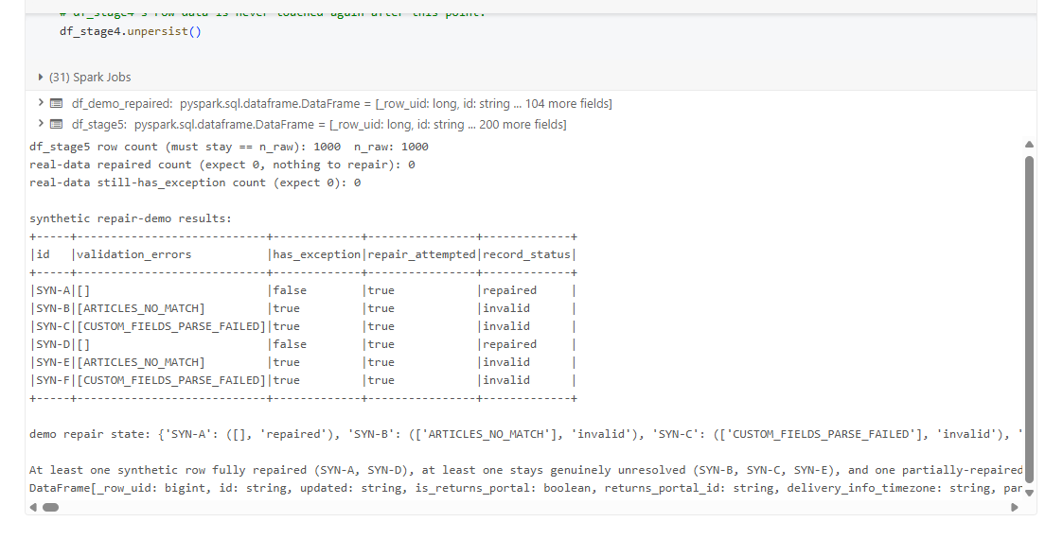

Task 3.3 — Route Unresolved Records
Synthetic routing demo: success = {SYN-A, SYN-D}, unresolved = {SYN-B, SYN-C, SYN-E, SYN-F} — matches the repair outcome exactly; df_success + df_unresolved reconciles to df_demo_repaired's full count.
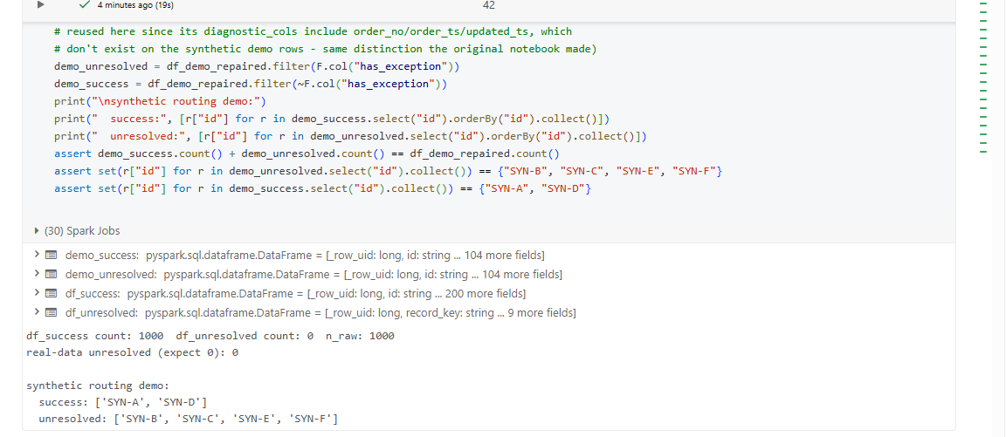

Task 4.1 — Produce the Final Transformed Dataset
df_final: 200 columns, 1000 rows, matching n_success exactly (no row filtering in the final SELECT). Spot-check of articles_json_* / custom_fields_json_* against the raw JSON for 3 sample rows.
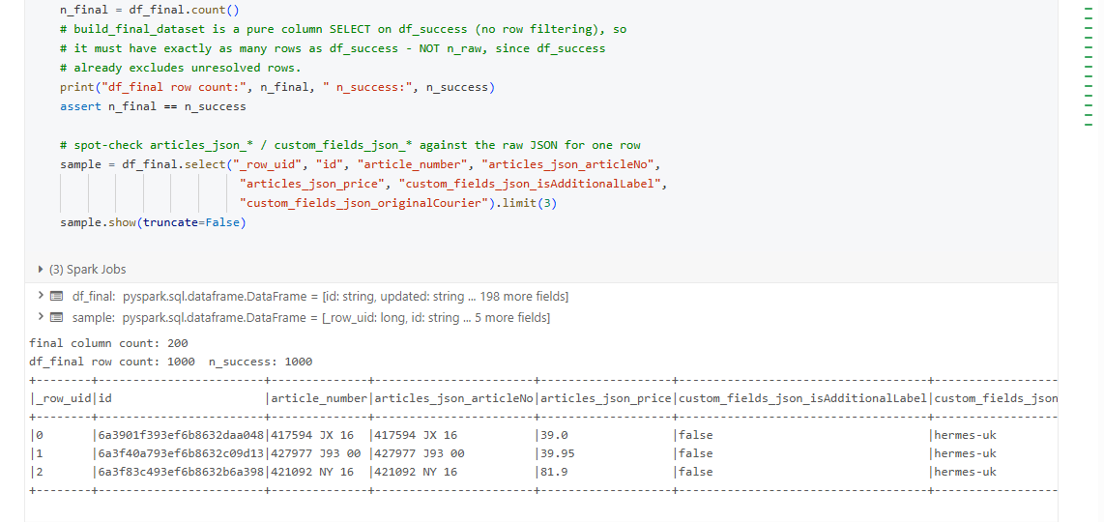

Task 4.2 — Optimise Datatypes
df_final_typed row count unchanged (1000); no boolean-prefixed columns left as string; full final schema printed for review.
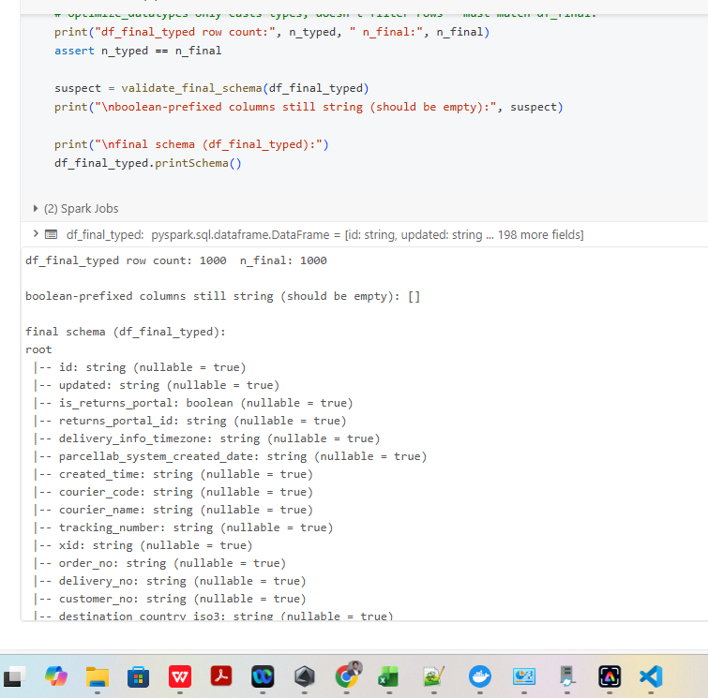

Task 4.3 — Save Final Dataset & Write Run Audit
pipeline_run_audit record written: run id, source table/version, start/completion timestamps, row counts, status SUCCESS.
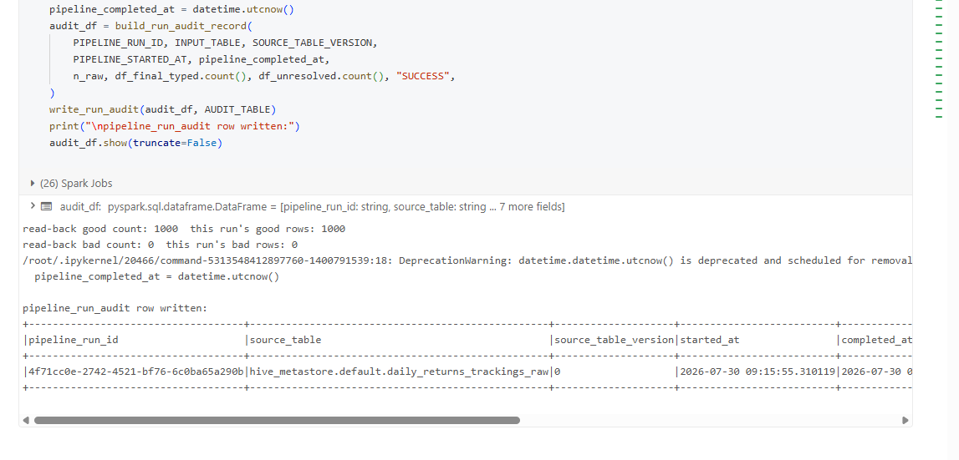

Final Summary & Catalog Confirmation
End-to-end reconciliation across the whole notebook, and confirmation that every output table actually landed in the Databricks catalog.
Final summary metrics: 1000 input rows, 1000 successfully processed, 0 requiring exception handling, 0 unresolved — all checks pass.
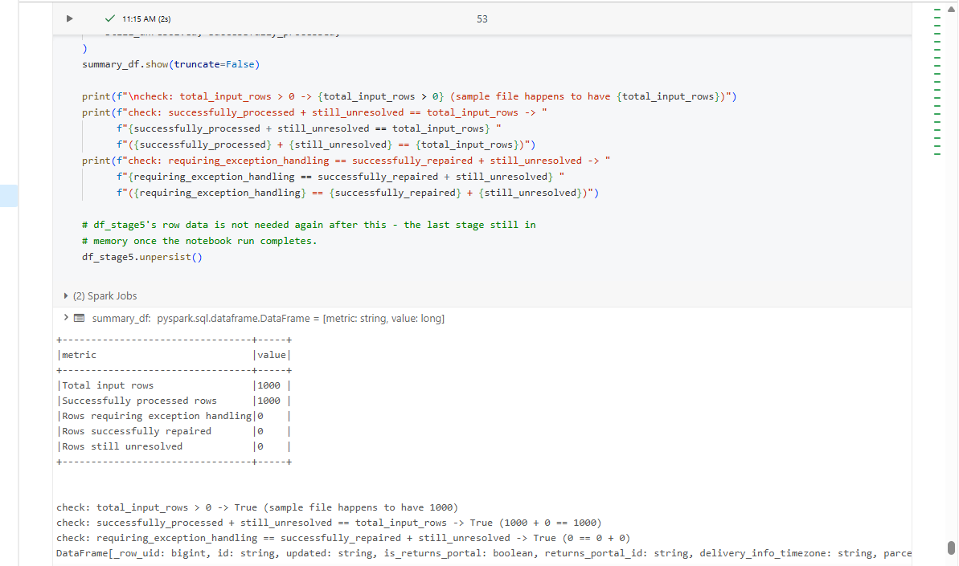

hive_metastore.default — all output tables present: daily_returns_trackings(_raw), pipeline_run_audit, returns_tracking_bad/exceptions/final/good.
